

**FACULTY OF COMPUTER & MATHEMATICAL SCIENCE**

**CSC584: ENTERPRISE PROGRAMMING**

**GROUP PROJECT**

**TITLE**  
PERFORMANCE REWARDS SYSTEM

**GROUP**  
NCS6A

**LECTURER’S NAME**

DR. MARSHIMA BINTI MOHD ROSLI

**GROUP MEMBERS:**

|  |
| --- |
| **NAME** |
| MOHD FAUZI RENTAH |
| AURI |
| NADZREEN |
| SUHAIMI |

**TABLE OF CONTENT**

|  |  |  |
| --- | --- | --- |
| **NO.** | **CONTENTS** | **PAGES** |
| **1.0** | **CASE STUDY** | **3** |
|  | 1.1 COMPANY BACKGROUND | **3** |
|  | 1.2 PROBLEM STATEMENT | **4** |
|  | 1.3 OBJECTIVE | **4** |
|  | 1.4 BUSINESS RULES | **4** |
| **2.0** | **ENTITY RELATIONAL DIAGRAM** | **5** |
| **3.0** | **3NF RELATIONAL SCHEMA** | **6** |
| **4.0** | **ENTITY RELATIONAL DIAGRAM NARRATIVE** | **6-9** |

1. **INTRODUCTION**

During unprecedented socio-economic crises like the current COVID pandemic, there is undeniable impact on corporate health and employee productivity.

From the employer’s perspective, it is critical how rewards and performances are aligned to bring back the desired productivity while continuing to optimise cost, quality and effectiveness without undermining the fundamental organisational values and core competencies.

1. **BACKGROUND & OBJECTIVES**

Peppermint Co is an established company in fashion design and apparel merchandise. They understand the importance of employee performance rewards and has decided to develop a simple, fast to market online system to manage the company rewards to its employees.

An organization incorporates reward management strategies for

1. Employee’s motivation
2. Encouraging performance
3. Recruitment and retaining
4. Supporting the company strategy

The system custodian is Rewards and Recognition Department under Human Resource Division.

1. **SOLUTION OVERVIEW**

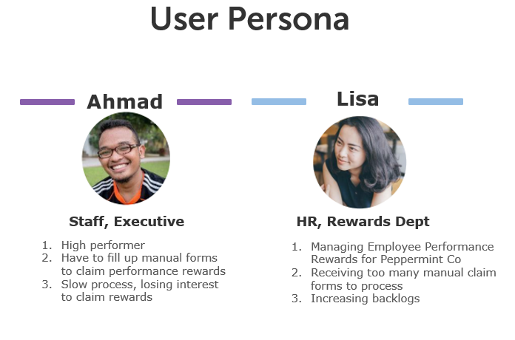

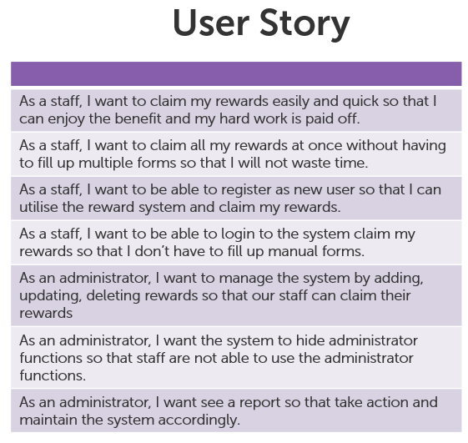

1. **SOLUTION DETAILS**

**Development Framework**: MVC

**IDE**:Netbeans 8.2

**Database**: JavaDB

**Programming Language**: HTML, Java, Javascript, jQuery, CSS.

**ERD Diagram**:

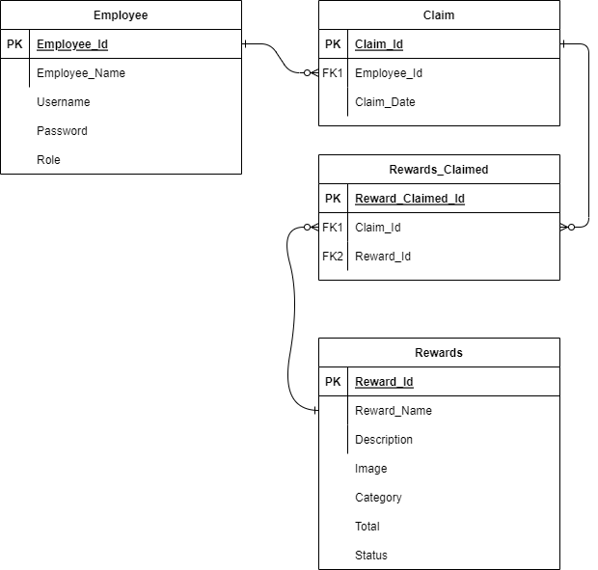

1. **DEPLOYMENT STEPS**
2. Open up insertVoucherServlet.java and update image location to reflect server folder.

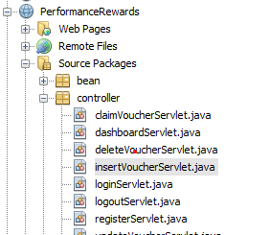

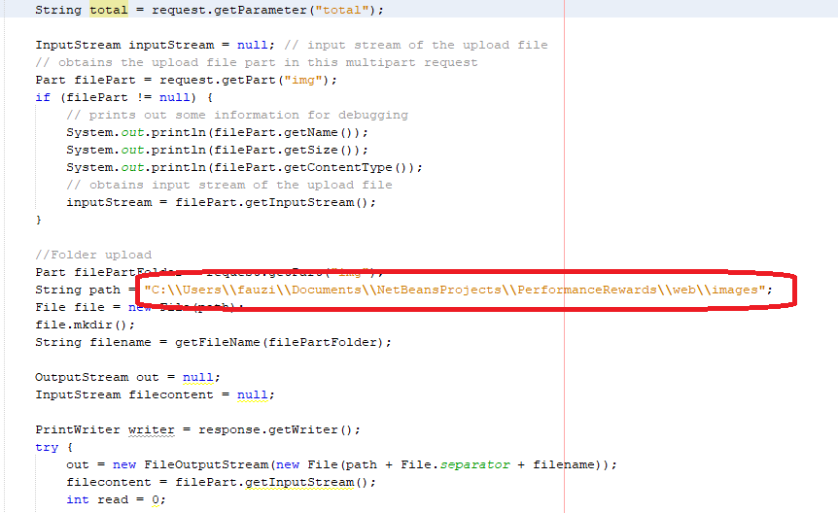

1. Build the package and copy .war file from distribution folder (<project folder\dist\>)

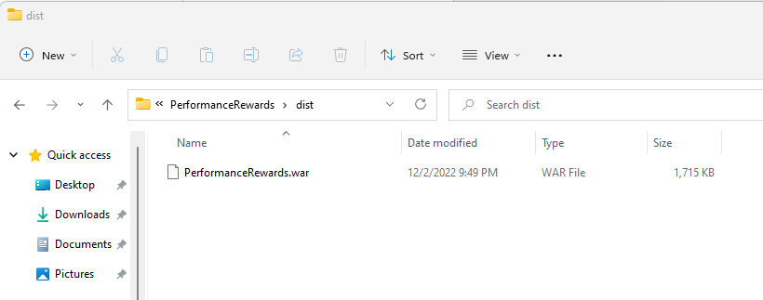

1. Login to web server (in this case, GlassFish) and go to Applications.

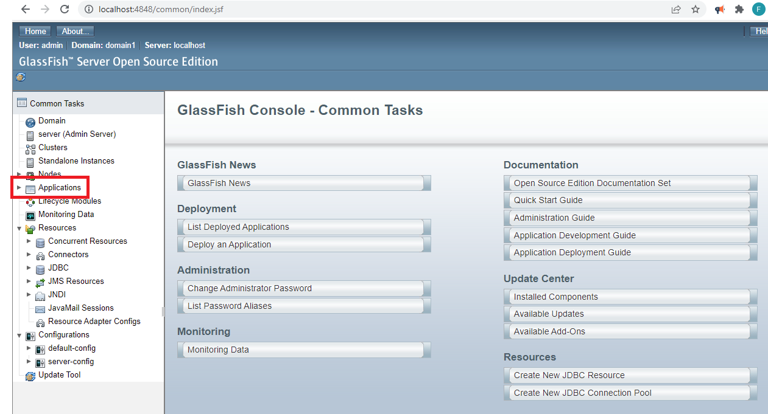

1. Click Deploy and upload .war file.

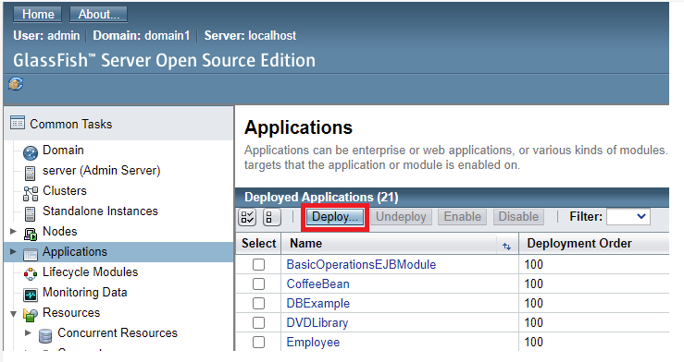

1. Click Ok to Deploy.

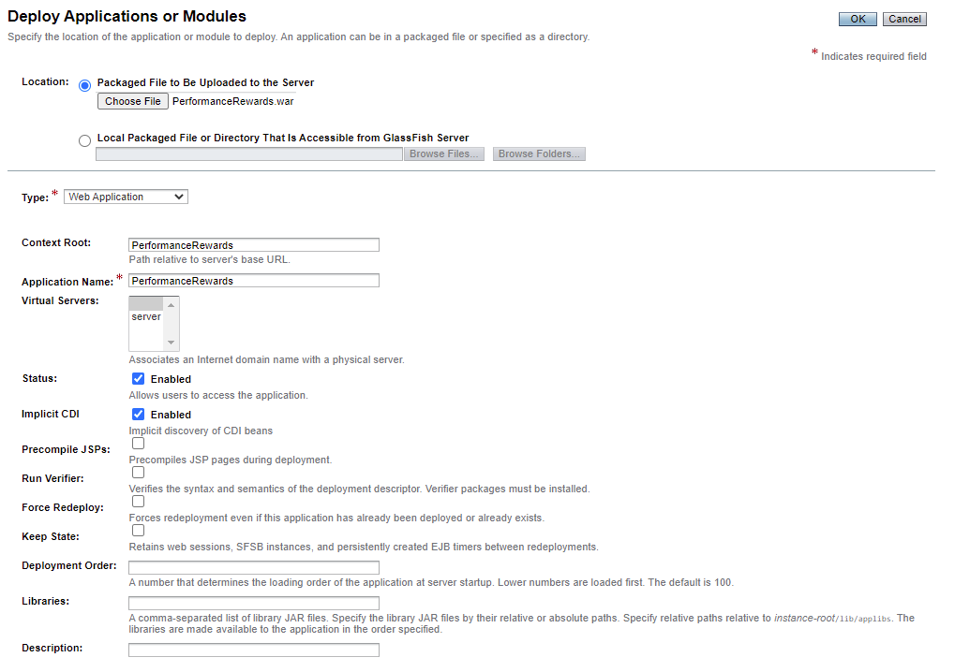

1. **SYSTEM WALKTHROUGH**
2. Upon launching the system from default URL, you will be greeted with the login screen. Click on ‘Login to Rewards Catalogue’ to invoke login dialog.

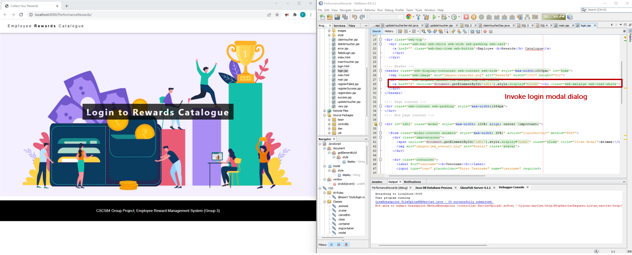

1. As a new user you will need to register. Click on register.

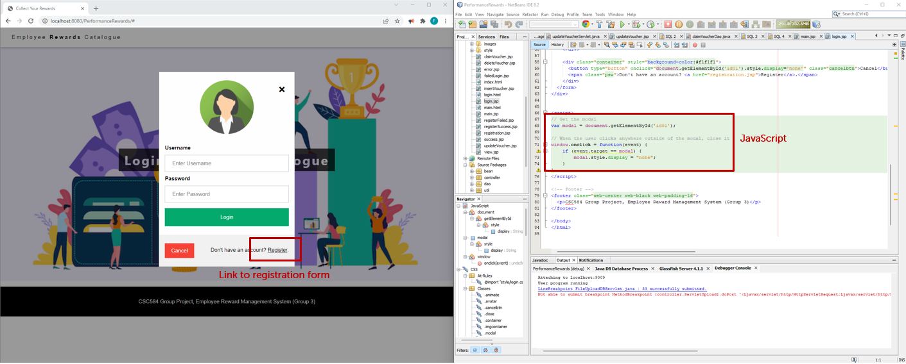

1. You can register your details or go back to login page by clicking Login.

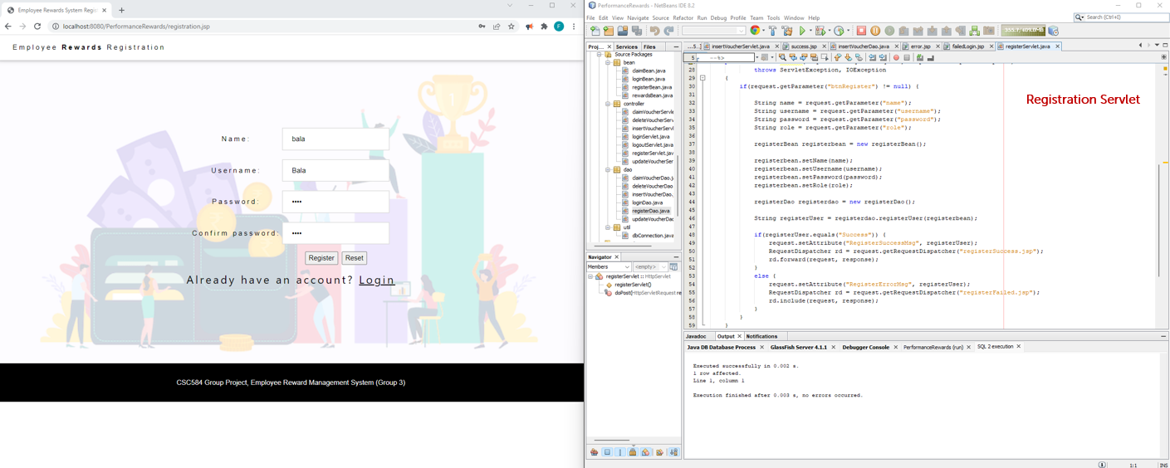

1. The system will auto detect for password mistmatch.

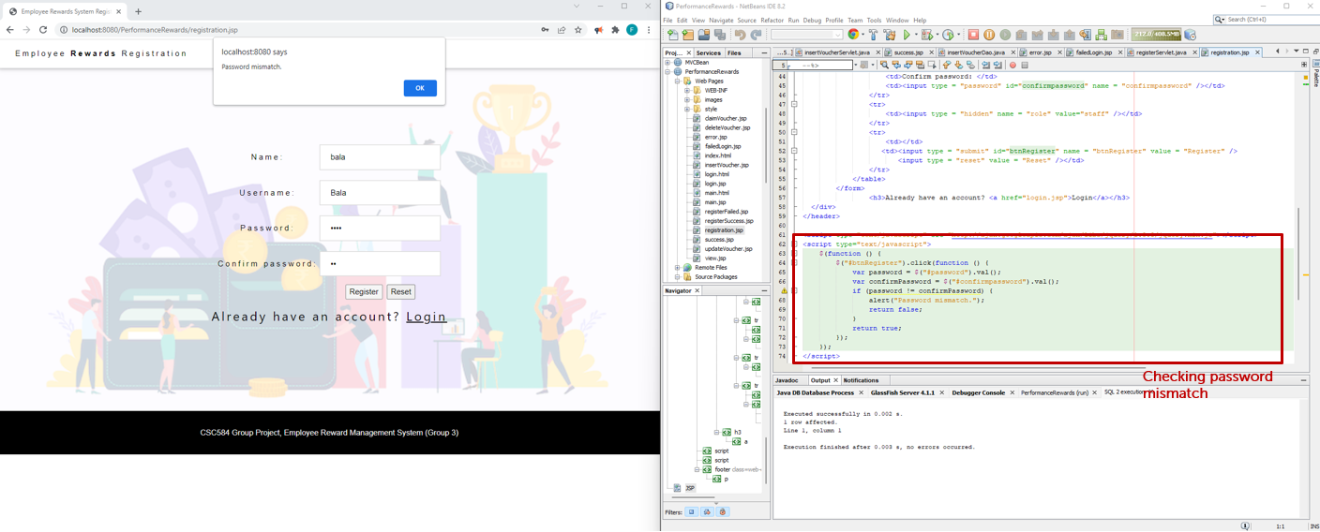

1. Upon successful registration, you will get success message and redirected to login page for login.

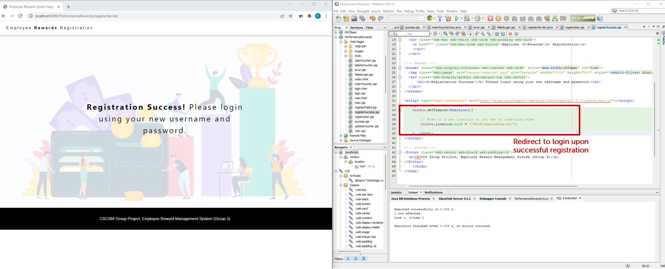

1. Enter username and password to login.

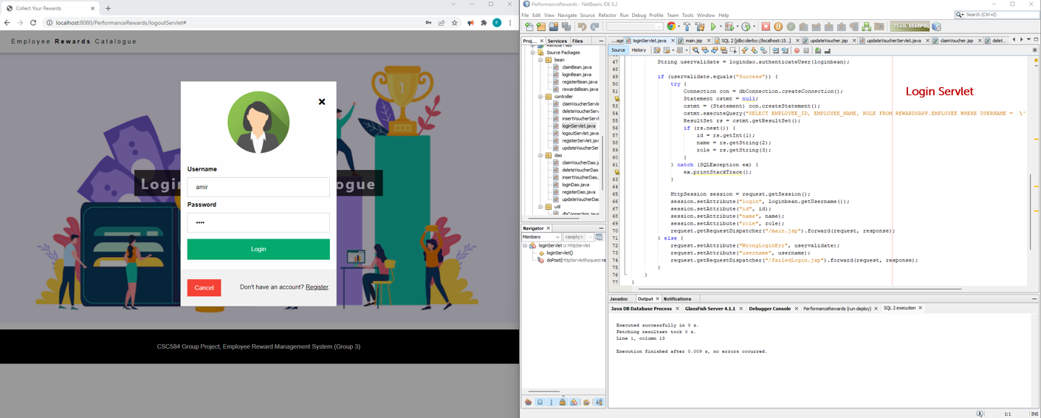

1. If you enter incorrect information, you will get error page and redirected to login.

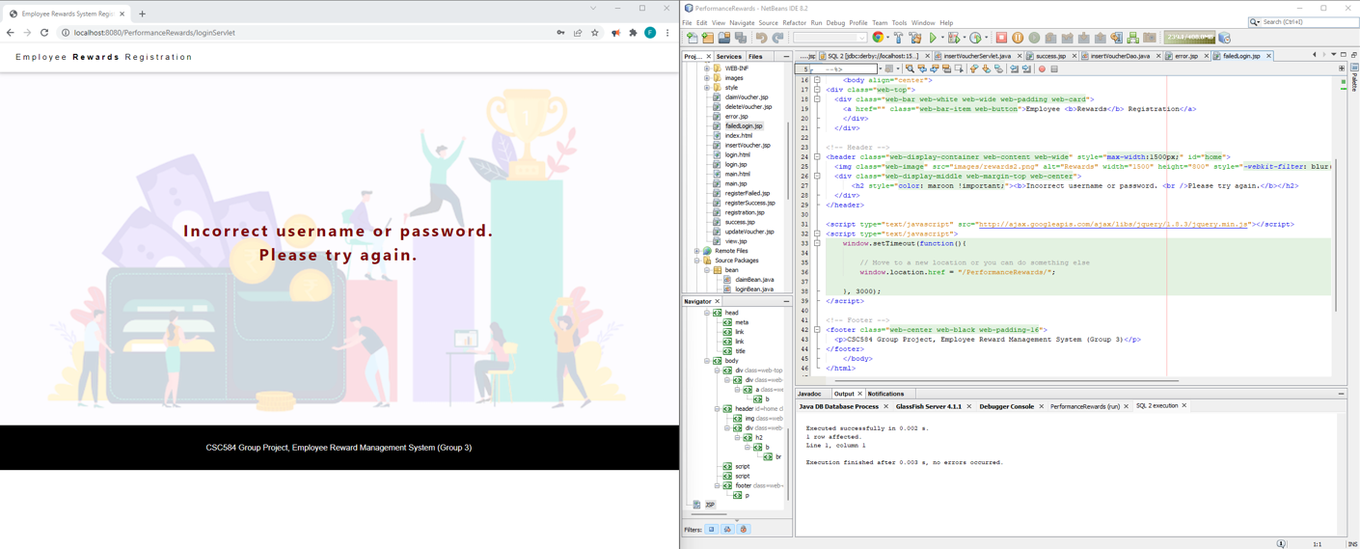

1. Upon successful login as a user, you will see a congratulations message and you can claim your rewards.

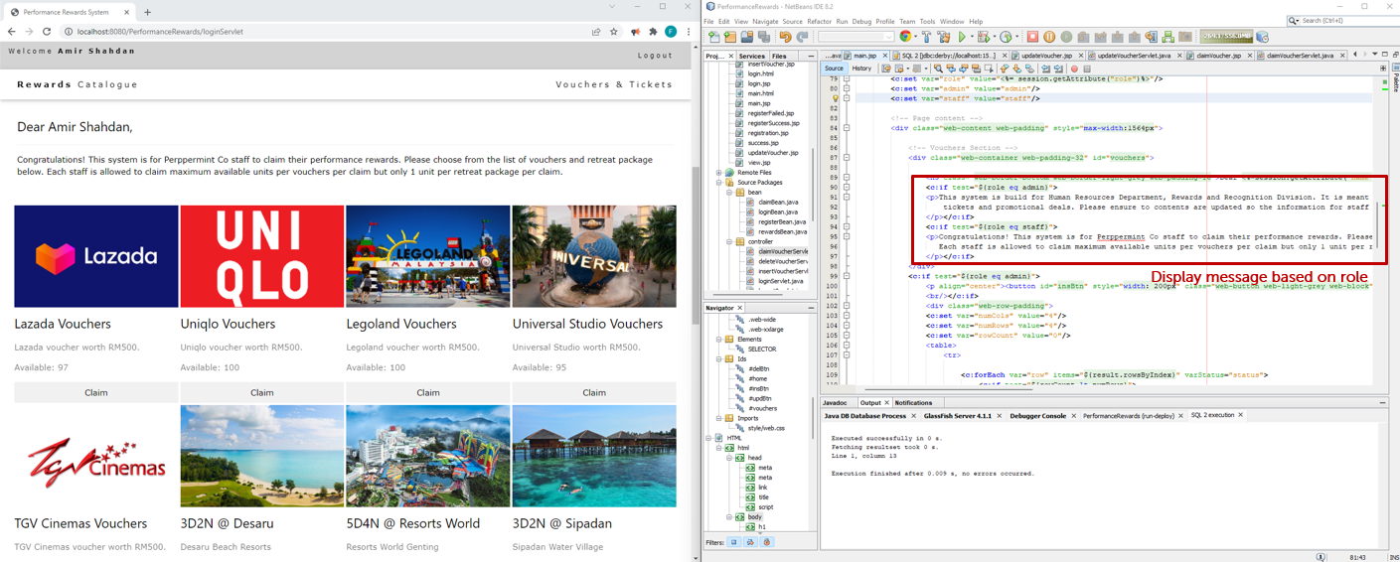

1. For rewards under voucher category, you can claim as much as what’s available however for staycation category, you can only claim one per transaction.

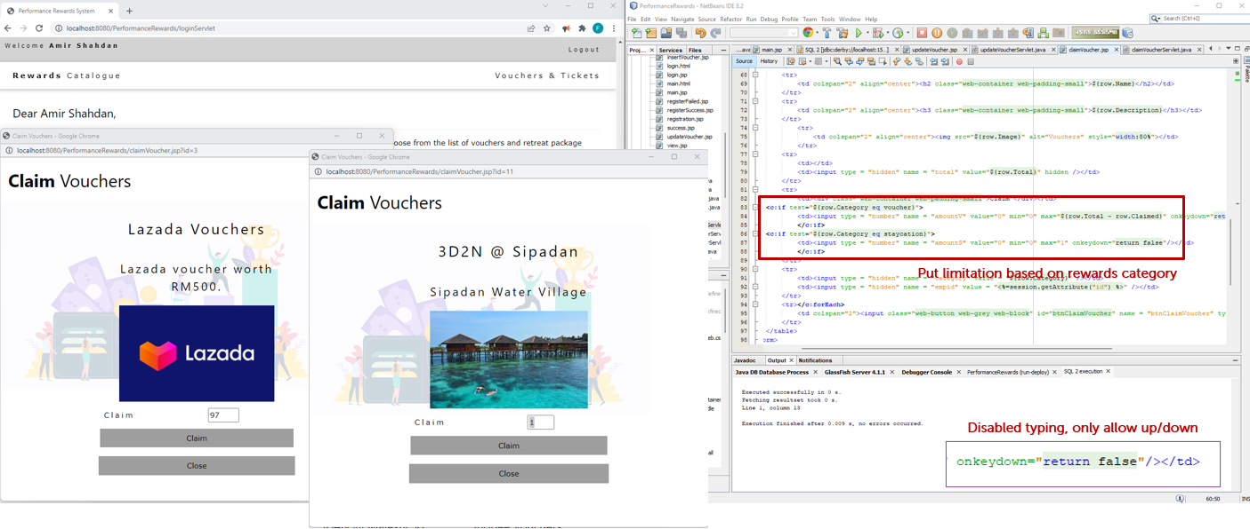

1. All successful transaction will get success message which will auto-close after a few seconds.

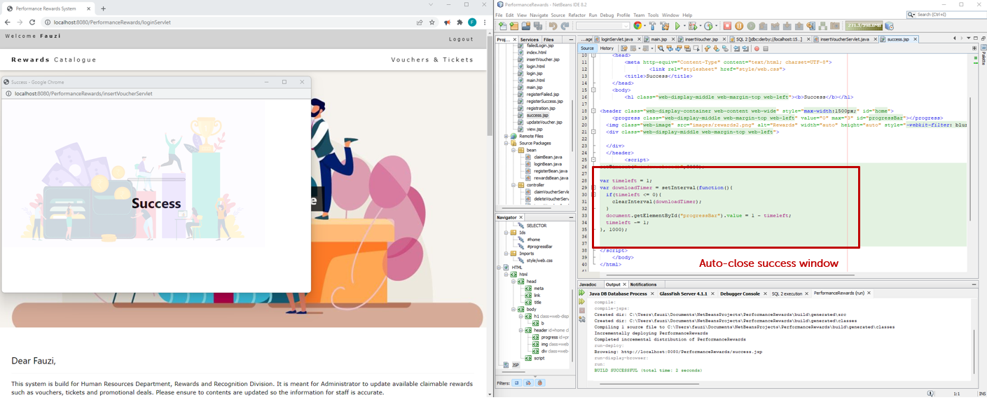

1. As system admin, you will be greeted with different message from user and have Dashboard button in the navigation bar to view reports. You will also get insert, update and delete button.

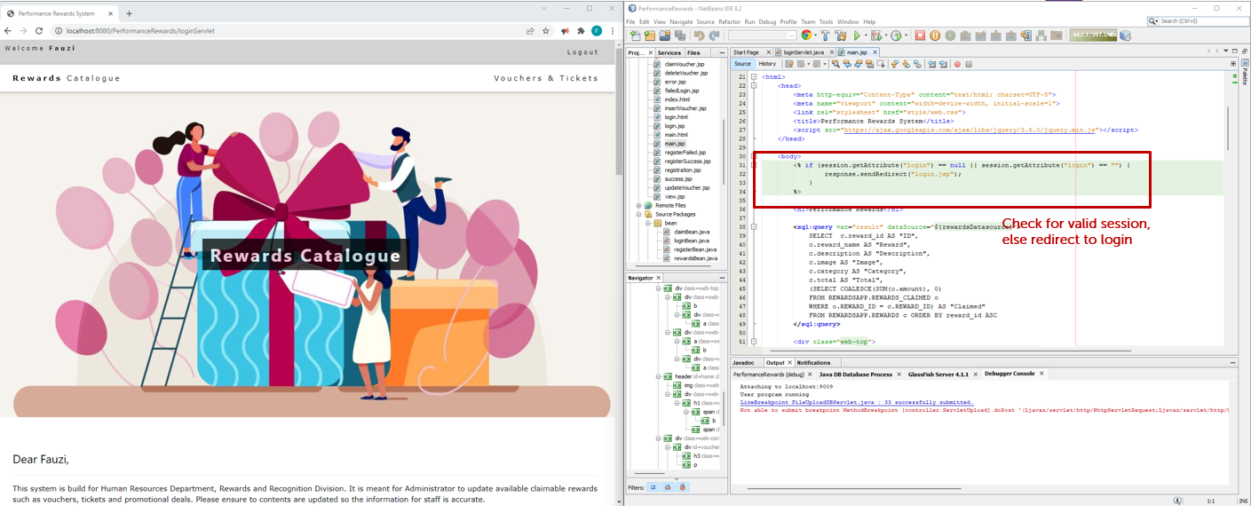

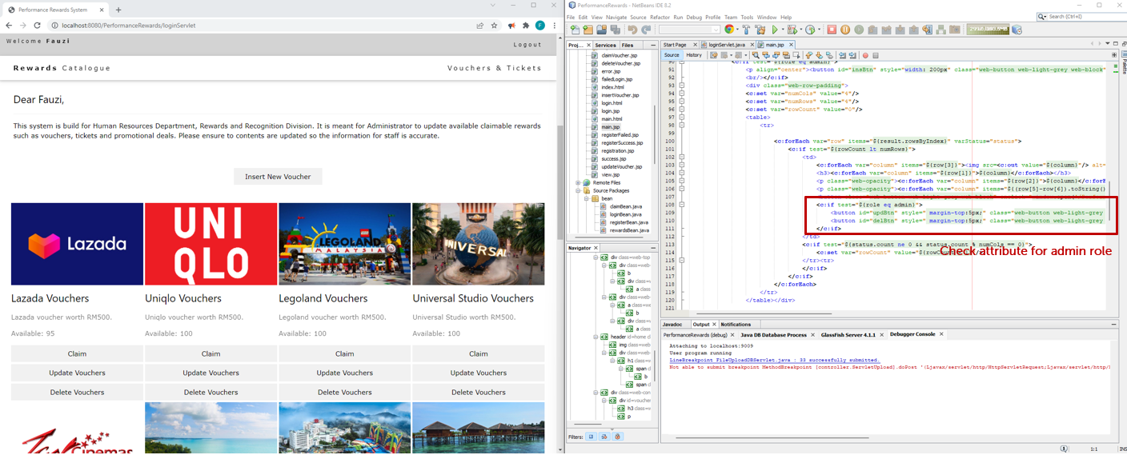

1. You can manage this system by inserting, updating and deleting (deactivate) the rewards.

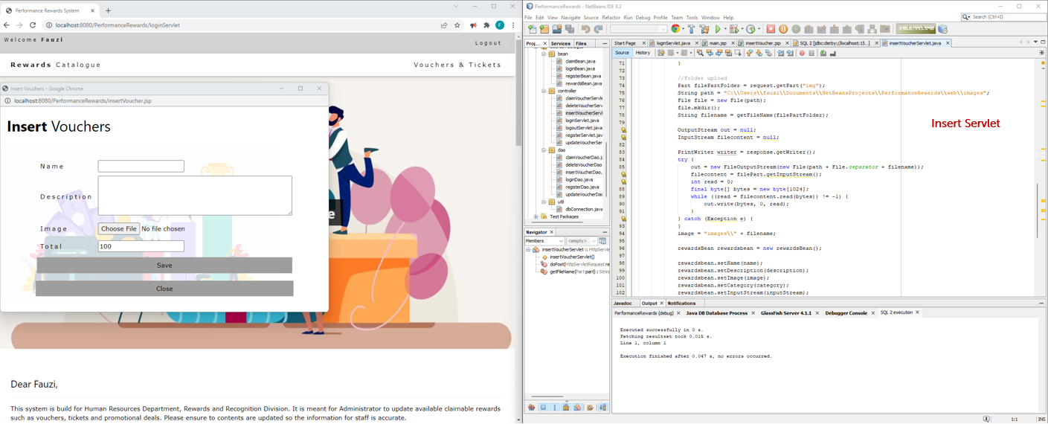

1. Please ensure image uploaded is 500x311px to ensure correct screen alignments.

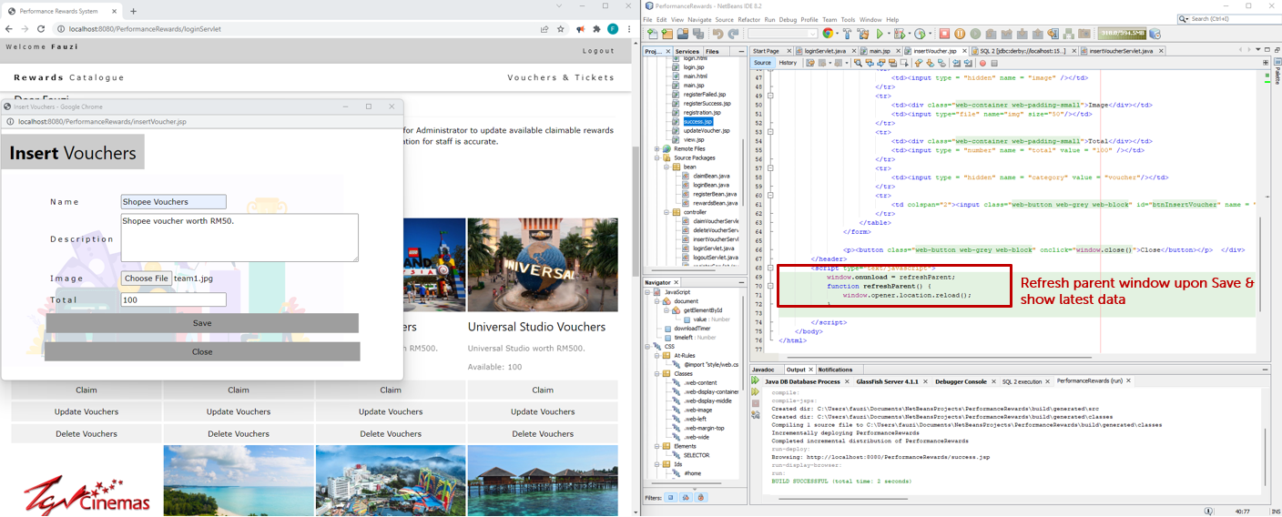

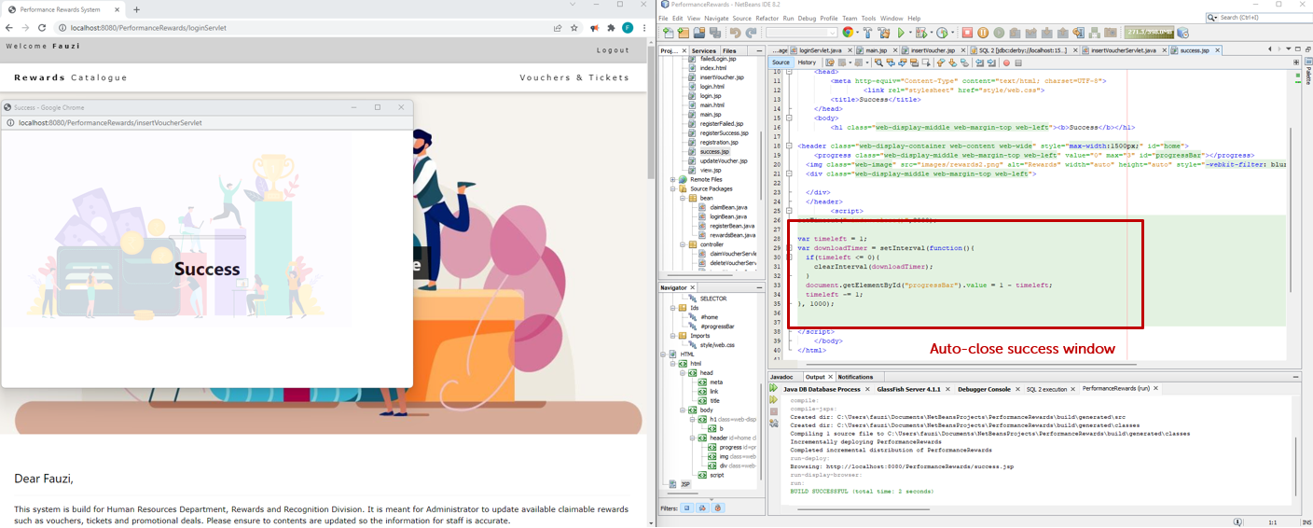

1. Sample of error message upon unsuccessful insert.

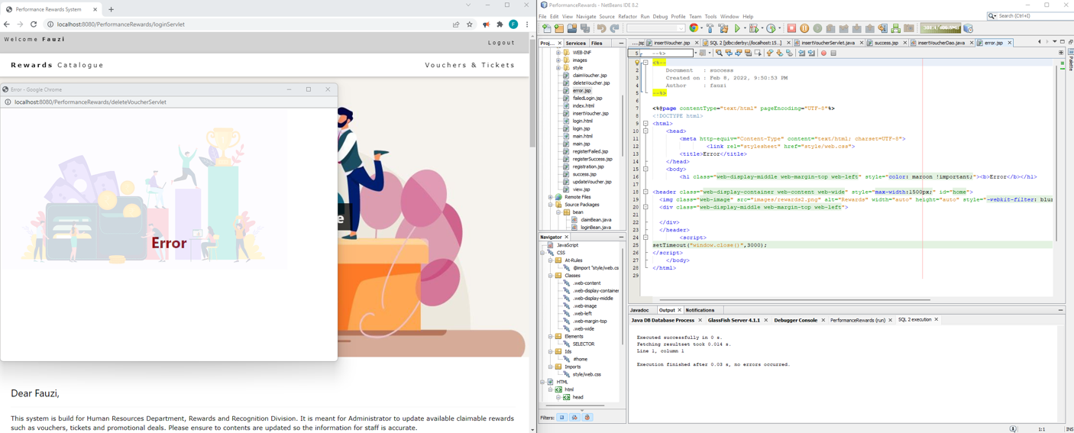

1. The rewards catalogue will only show active vouchers.

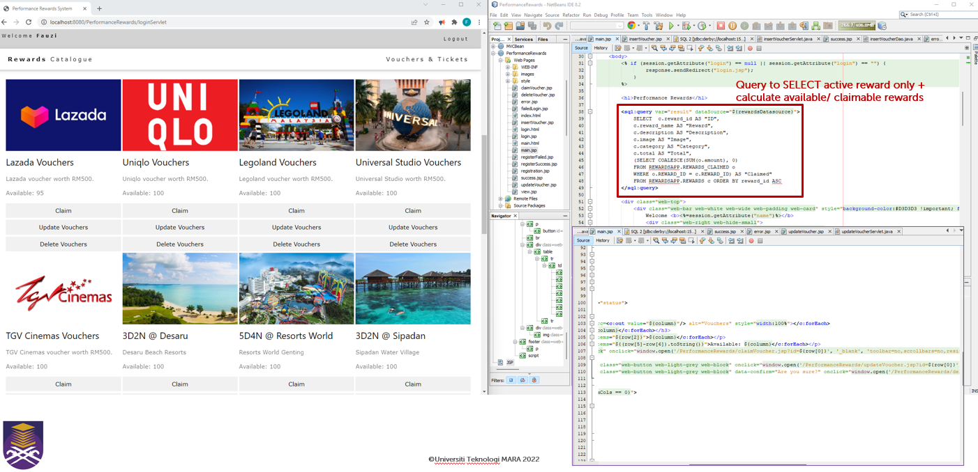

1. Update and delete window will auto-populate the fields.

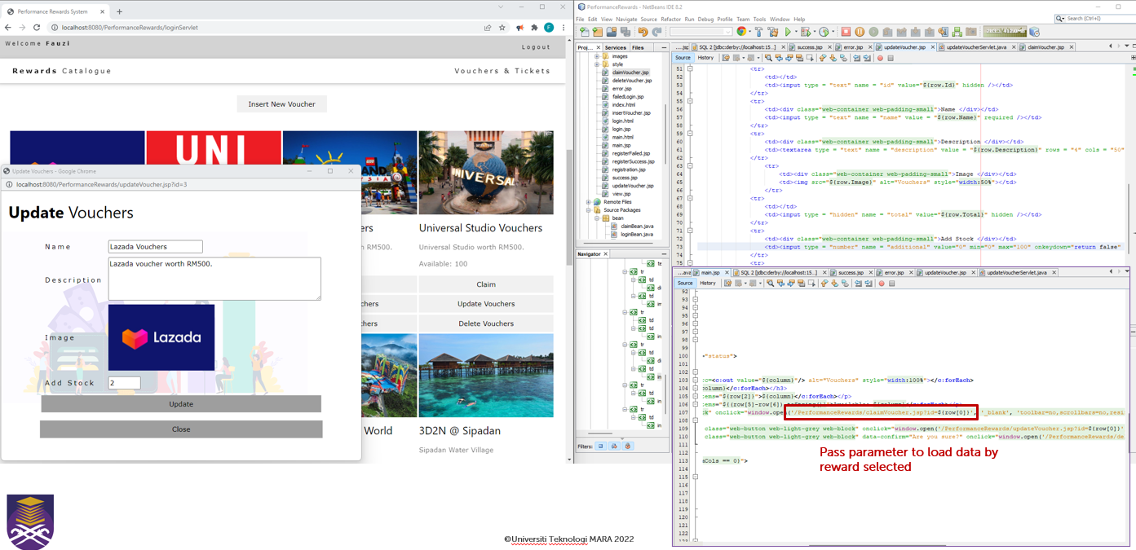

1. Update servlet.

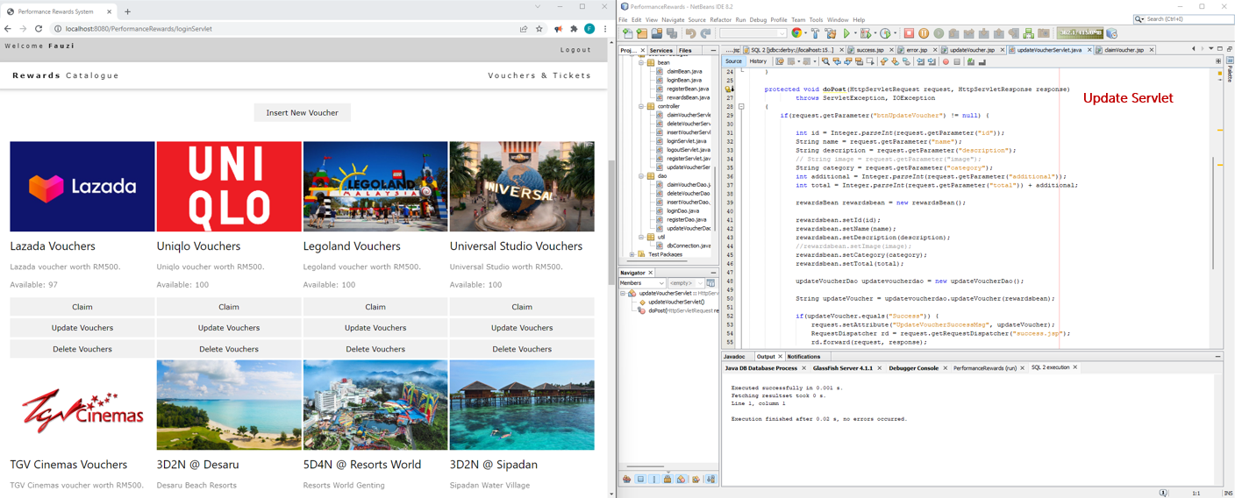

1. To ensure reports are accurate, rewards are not deleted from database but set to inactive.

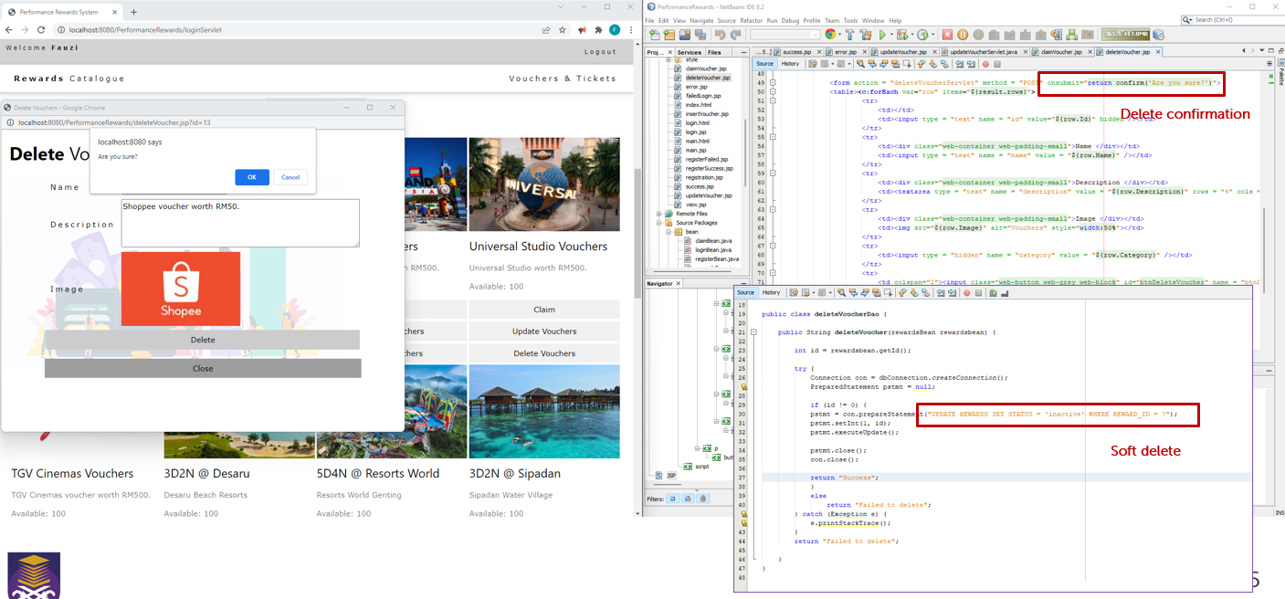

1. As admin, you can view the reports page by clicking ‘Dashboard’ from nav bar.

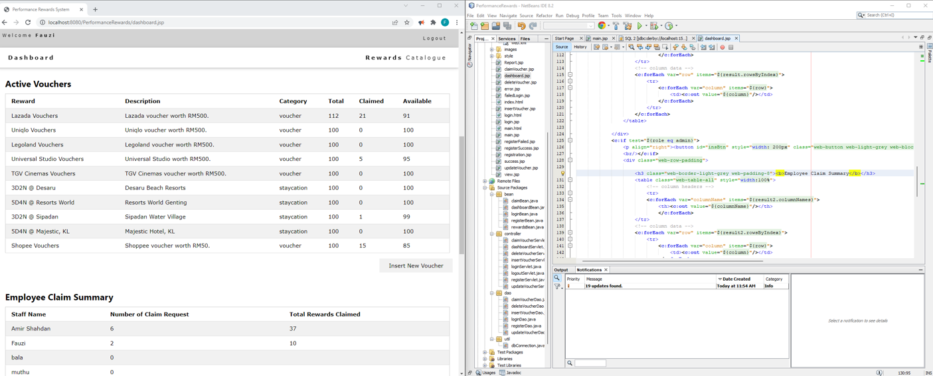

1. Logout to logout from system.

